***Final Project***

|  |  |  |
| --- | --- | --- |
| Name | ID | Group |
| Amr Mohammed | 20206049 | S7 |
| Maryam Khamis | 20206160 | S7 |
| Mazen Ayman | 20206057 | S5 |

The dataset we used in a project is :

Gender Classification Dataset (kaggle.com)

* To run file change Directories to your directory that dataset exist :

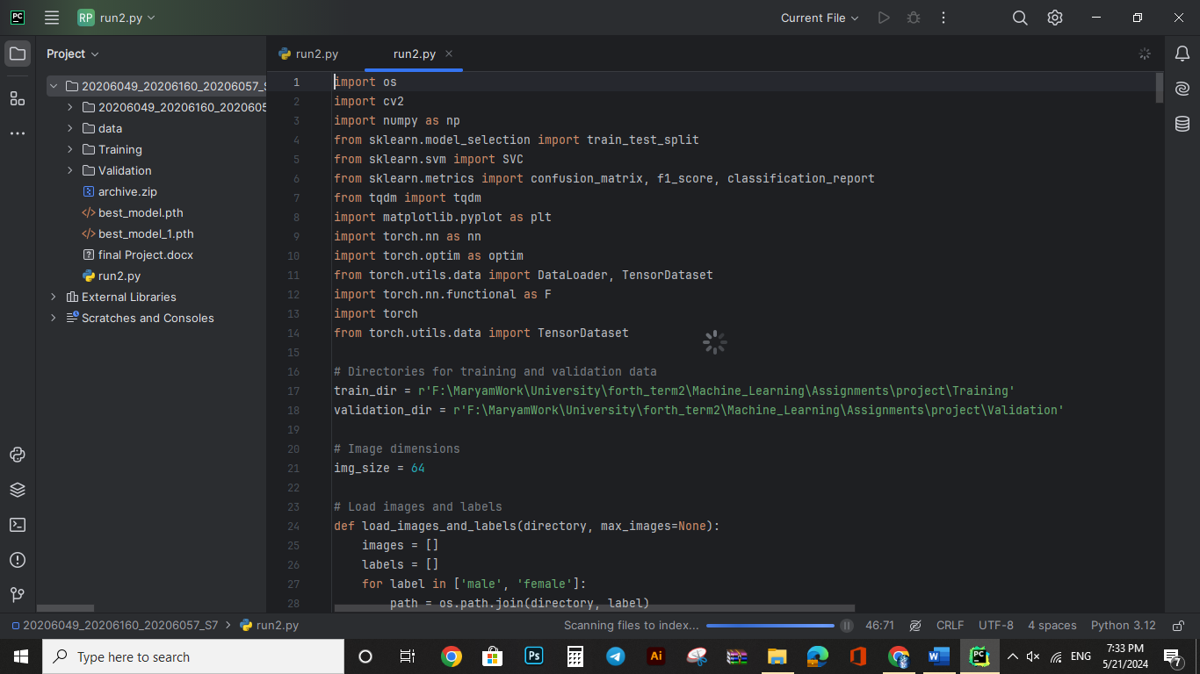

* And you can change the number of max images as you want to run it here:

Screenshots:

SVM Part:

Neural Network Part:

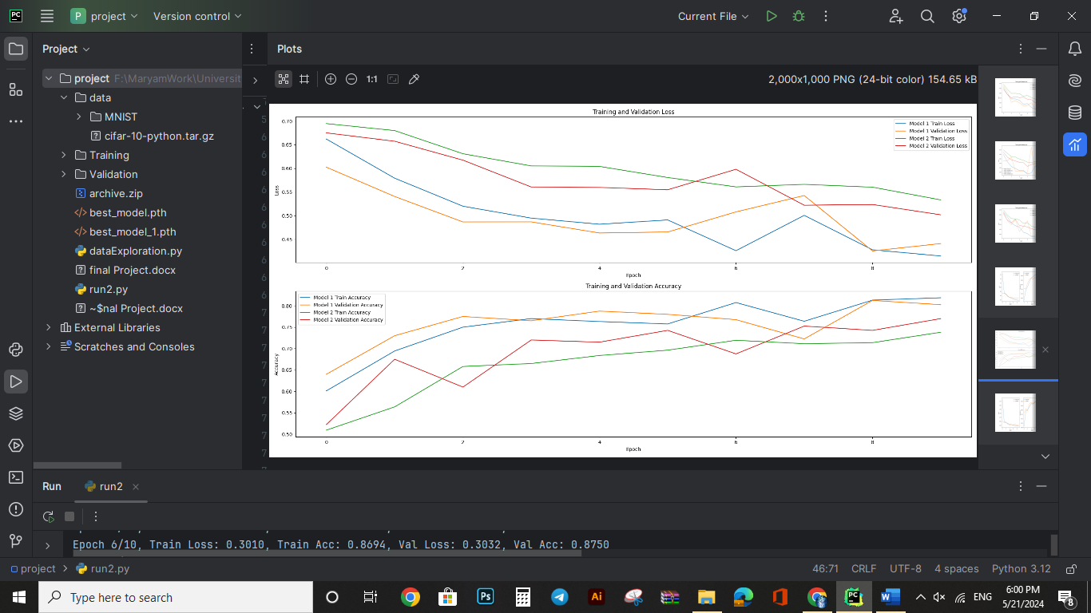

Convolutional Neural Networks:

Compare:

